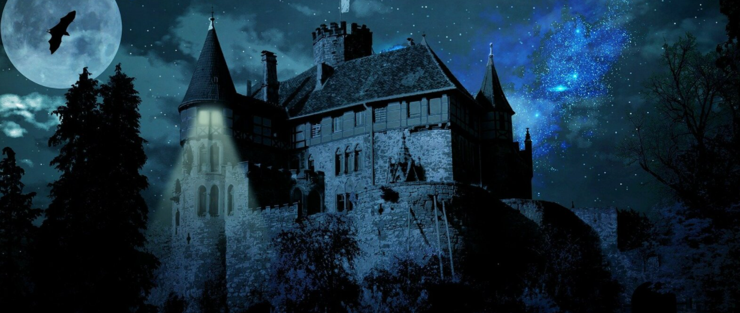
D My expanded noun phrase is
A My action word is
D My dialogue will be
W My ‘where’ fronted adverbial is
A My ‘ly fronted adverbial is
V My verb sentence starter is
E My estimation of time is
R My rhetorical question is
S My simile is

It was the dead of night.

